PostgreSQL Basics

1.Create database:

Create database database_name;

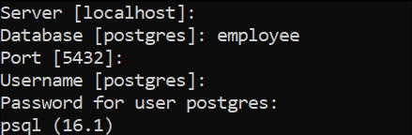

2.Create table:

Create table table_name(column1,column2,…column n);

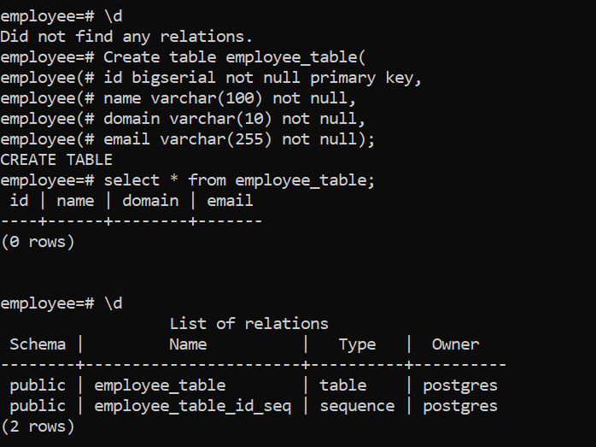

3.Insert values:

Insert into table_name(column1,column2,column3) values (value1,value2,value3);

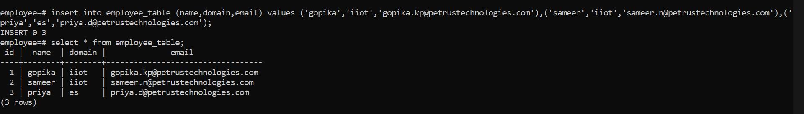

4.Alter table:

Alter table table_name add column k type column_name_type;

Alter table table_name alter column column_name type column_name_type;

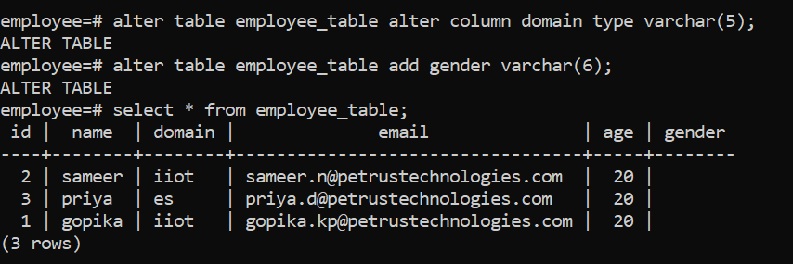

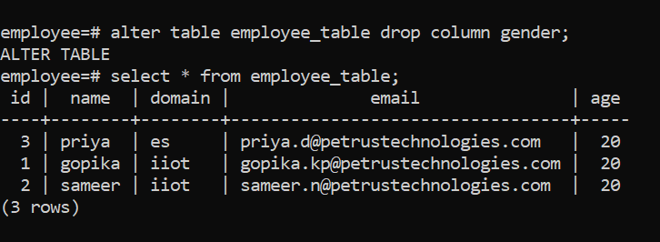

5.Update:

Update table_name set value where condition;

If condition is not specified then it updates all the values;

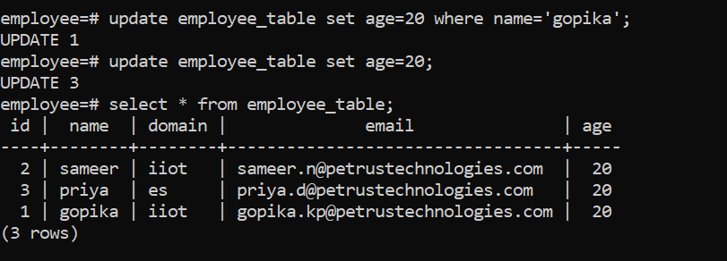

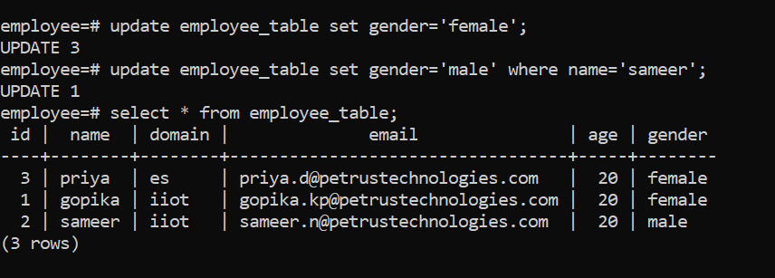

6.Order by:

Select * from table_name order by id asc\desc;

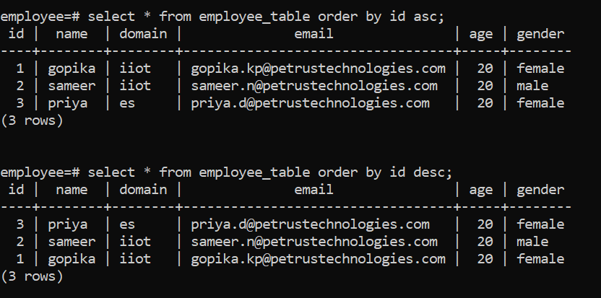

7.Delete:

Delete from table_name where condition;

Delete from table_name;

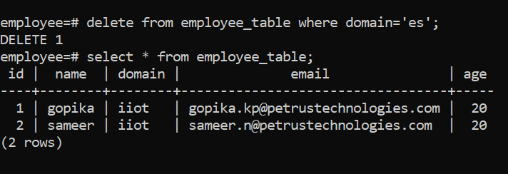

8.Truncate:

Truncate table table_name;

9.Drop column and table:

Alter table table_name drop column column_name;

Drop table table_name;

10.To view relations:\d

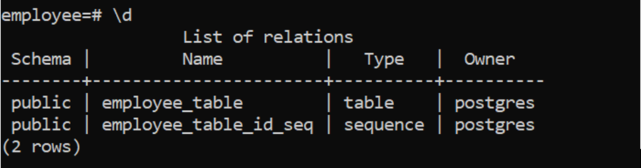

11.To view in expanded manner:\x

